Project 1 Objective:
To create a ‘mobile first’ application that provides demographic, climatic, geographic and other data for countries selected by the user. Other data may include (but not limited to) a selected country’s currency, currency exchange rates and national flag. Upon loading the app, the user should have their device location display on a map with the country that they are in highlighted. The other data should be displayed on the screen as well.
Project 1 Program Flow:
This app is not being distributed via a digital distribution service. It is accessed via: https://www.benwillan.co.uk/project1/index.html

- After visiting the above link a jQuery ‘on load’ function will fire to run a preloader. This is done for 2 reasons. 1: to provide the user with feed back that the app is loading. 2: prevent interaction until the map has loaded fully and the app is in a ready state.
- The ‘on load’ function retrieves the device location using JS Navigator and draws the highlighted border around the country they’re in.
- Country information is then retrieved with AJAX calls to PHP routines which receive the corresponding data from the relevant APIs.
- This country information is displayed in a bottom hidable panel underneath the map area.
- Other country selections can be made by typing an entry into the top (mobile) or bottom (desktop) panel and the UI will update accordingly.
Project 1 Wireframe UI concept:
Four components make up app UI: The scrollable map tiles, Country Select input and datalist with autocomplete feature, Country Info area and a ‘Return To Home’ or ‘Current Location’ that resets the map position to the initial position or current location.
Desktop
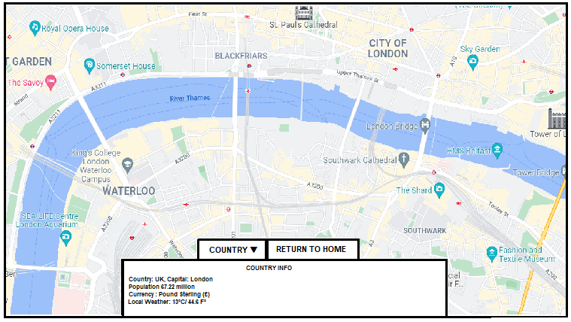

Mobile
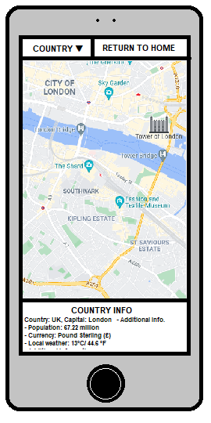

Project 1 How I would implement API’s and other tools:
- OpenCage API – used to generate string names for the current location by passing JS Navigator co-ordinates via AJAX/ PHP routine.
- OpenWeather API – used to provide weather information including temperature and weather descriptions.
- The use of free icons from https://iconstore.co/icons/15-colored-weather-icons could be used for a graphical display of weather conditions or alternatively an OpenWeather weather widget. Other icons for use with currency could be used.
- https://flagpedia.net/download/api - provides the means for displaying country flags.
- Geonames.org – Country Info API to provide population statistics and country square. https://www.geonames.org/export/web-services.html#countryInfo
- Open Exchange Rates API – providing currency rates.
- GitHub – version control and feedback of source code.
- countryBorders.geo.json
  - used in conjunction with Leaflet API to generate the country border the user is in on app load.
  - JSON data can be parsed to provide a list of all the worlds’ countries and values for <datalist> used by <input>.
- Amadeus - https://developers.amadeus.com/self-service/category/destination-content/api-doc/points-of-interest/api-reference. Used to highlight points of interest and small number of popular tourist attractions for different countries.
- Bootstrap3 to be employed for responsive design and styling purposes.

